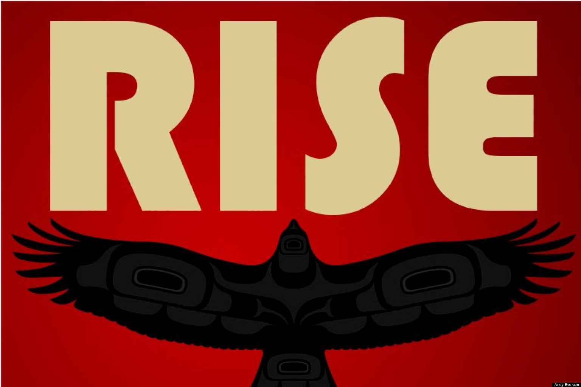

**I am so excited to be your teacher this year! I cannot wait to learn with you!**

**Assessment**

**Summative**

*This evaluates your learning – think of it as “summing up” what you have learned. It is used to make your final grade. Summative work falls under:*

• Written assignments

• Projects

• Presentations

**Formative**

*This tells Ms. Tkachuk how you are progressing in your learning during summative tasks and classwork. Feedback about your formative growth will help you understand how to achieve what you are capable of. Formative work falls under:*

• In-class work

• Conversations

• Student reflections

**Evaluation Scale**

Mastering (MAS) 90% - 100%

- *Can apply the learning to complex tasks independently.*

Advancing (ADV) 80% - 89%

- *Can apply the learning to increasingly difficult tasks with prompts.*

Progressing (PRG) 70% - 79%

- *Can apply the learning to moderate tasks with support.*

Emerging (EMG) 60% - 69%

- *Can apply the learning to basic tasks with guidance.*

Beginning (BEG) 50% - 59%

- *Can apply the learning to simple tasks with direction.*

Limited (LIM) less than 50%

- *Cannot yet apply the learning to simple tasks. Extensive support required.*

*“The answer is not to standardize education, but to personalize and customize it to the needs of each child and community. There is no alternative. There never was.”*

*-Ken Robinson*

**Assignments**

**Current Events**

Throughout the year, we will address current events happening in our world. You will be periodically required to write responeses to questions posed during current events.

**Project Work**

As a class, we will be working together to answer questions that we have about worldviews affecting other worlds. Using every resource available to us (field trips, guest speakers, technology, etc.) we will learn about what happens when a new worldview is introduced into an already established world. We will present our findings in (almost) limitless forms and share these with the surrounding community.

**Notes**

We will take notes throughout the year as we have lots to cover about Canada’s history. Please keep this section of your binder neat. DO NOT THROW AWAY YOUR NOTES - YOU WILL NEED THEM LATER!

**Written Responses**

Writing is an excellent way to explore explore your understanding of certain topics. We will utilize your writing skills throughout the year. We will use our textbooks to guide some of these responses, but we will also respond to our learning through writing in other aspects.

**Assessment**

This is a place to store any rubrics or assessments throughout the year. DO NOT THROW AWAY ASSESSMENTS – they are a great way to track your growth as a learner.

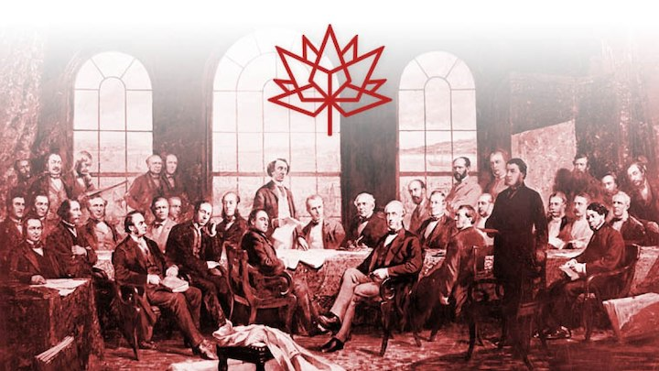

**Welcome to Social Studies 7/8!**